|  |  |
| --- | --- |
| **Name** | Farhan Arif, M. Adeel |
| **Reg. No** | 2019-EE-405, 433 |
| **Marks/Grade** |  |

EXPERIMENT NO. 13

# Perform steady state analysis and stability analysis of synchronous Machine.

**Objective:**

At the end of this lab session students will be able

* To accurately select the parameters of generator control and fault recovery time for steady state analysis.

# Introduction:

The synchronous generator is also known alternator that transforms mechanical energy that is provided by its prime mover at shaft into electrical energy at specific voltage and frequency. Its rotation speed is known as synchronous speed because its rotation speed equals the speed of rotation of field at stator that known as synchronous speed.

When the torque provided to the shaft of the synchronous generator by the prime mover orthe load connected with the generator varies abruptly, then transients produce in the generator that will remain until the generator again gets the stability.

For instance, when the generator is connected in parallel with the already working power system, as we discussed in Parallel Operation of Synchronous Generator that the incoming generator frequency should be higher than the running system, so its frequency is larger than the system. When a generator is paralleled, there are transient’s intervals before it works steadily and starts to operate at the frequency equal to the system.

# Transient Stability of Synchronous Generators:

As we know that the extreme power that a generator can provide to its load at any condition is known as the **static stability limit** of a synchronous generator.

The maximum power that a generator can provide to load is given here.

***Pmax = 3VøEA/Xs***

And the maximum torque of the synchronous generator is given here.

***tmax = 3VøEA/wXs***

Theoretically, the generator should provide torque and the power to that above-

given quantity before becoming unbalanced. But practically due to the dynamic stability boundary the extreme power that can be provided by the generator is restricted to a lesser level.

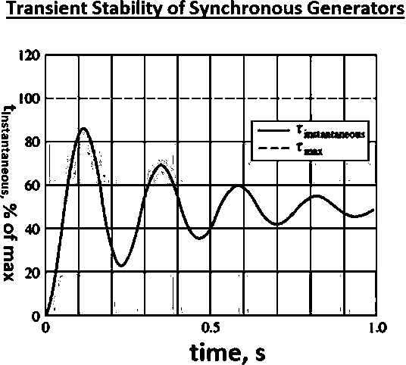

**Figure 13.1** Transient Stability Graph

The significant point above diagram is that if at any point in the transient response the instantaneous torque surpasses **Tmax**, the generator will lose its stability. The amplitude of the oscillations relies on how abruptly the extra torque provided to the generator.

If the load is connected abruptly with the generator, the generator will be steady only to a very lesser limit, it is very complex to measure. For each sudden variation in torque or load, the dynamic stability limit can be less than half of the static stability limit.

# Short-Circuit Transients in Synchronous Generators:

The most dangerous transient situation that can occur in a synchronous generator is the point when the 3 phases of the generators relate to each other. This type of connection (short circuit) among three phases is known as the fault.

There are numerous mechanisms of current present in a short-circuited synchronous generator, that are defined here. The similar facts occur in less dangerous transients like load variation, but they are very understandable in the dangerous case of a short- circuit. When the terminals of the generator are short-circuited, the resultant current flowing the 3 phases of thegenerator.

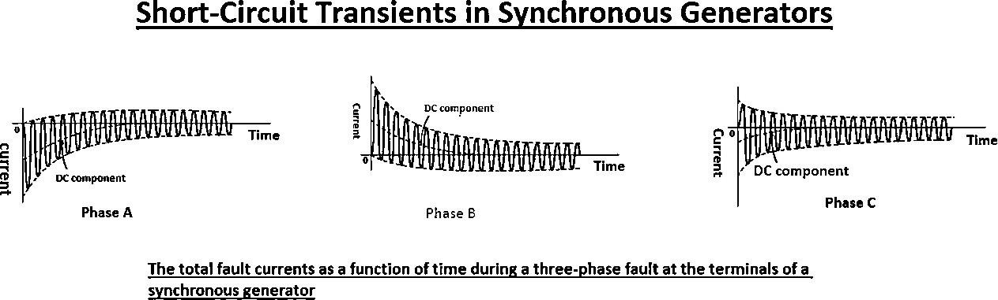

**Figure 13.2** Short Circuit Transients in Phase Currents

The pictorial representation of the alternating current symmetrical component of current is shown here.

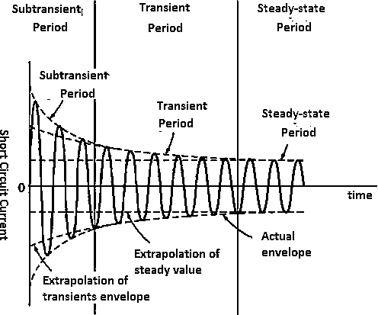

**Figure 13.3** Symmetric AC Component of Fault Current

The alternating current components are divided into the 3 main time periods. after the short circuit (fault) occurrence you can see that the alternating current amplitude

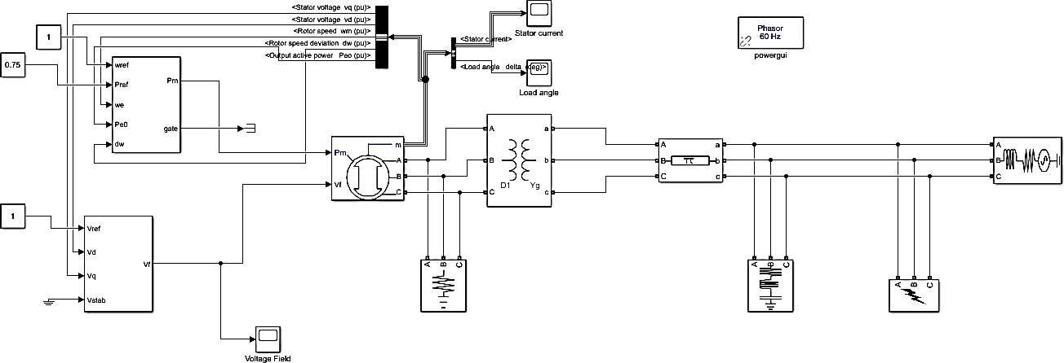

is very high, and its decays very fast. This interval is known as the sub transients.

After the sub-transient period the large amplitude of the current continues to decay slowly, finally it get steady state. The time interval in which the amplitude of the current decay slowly is known as a transient period and interval then it gets steady- state condition is called steady state period.

# Single Machine Infinite Bus System:

Single Machine Infinite Bus System (SMIB) is a test bus system where one can study the transient response of Synchronous Generator and Effect of Faults on the transmission line. In this case, the SMIB model is designed in MATLAB Simulink Environment.

This model can be used as the base model for studying the transient response in various conditions and one can employ techniques to improve the transient response of the Synchronous Generator.

The infinite bus has been modeled via 3 phase voltage sources, this ensures that the voltage and frequency of the system will not change during sudden load.

# Setting and results of power diagrams: MATLAB Simulink Model:

**Figure 13.4** MATLAB Simulink Model of Synchronous Machine

**Load Angle:**

# Stator Current:

**Figure 13.5** Graph of Load Angle of Synchronous Machine

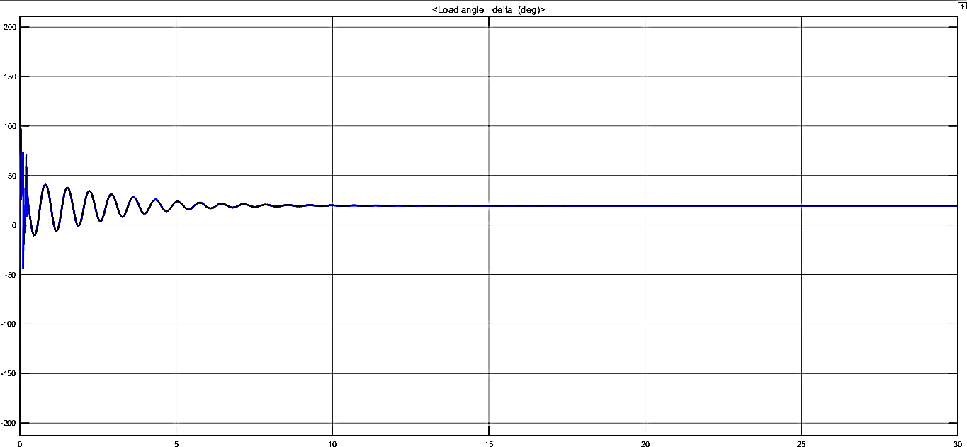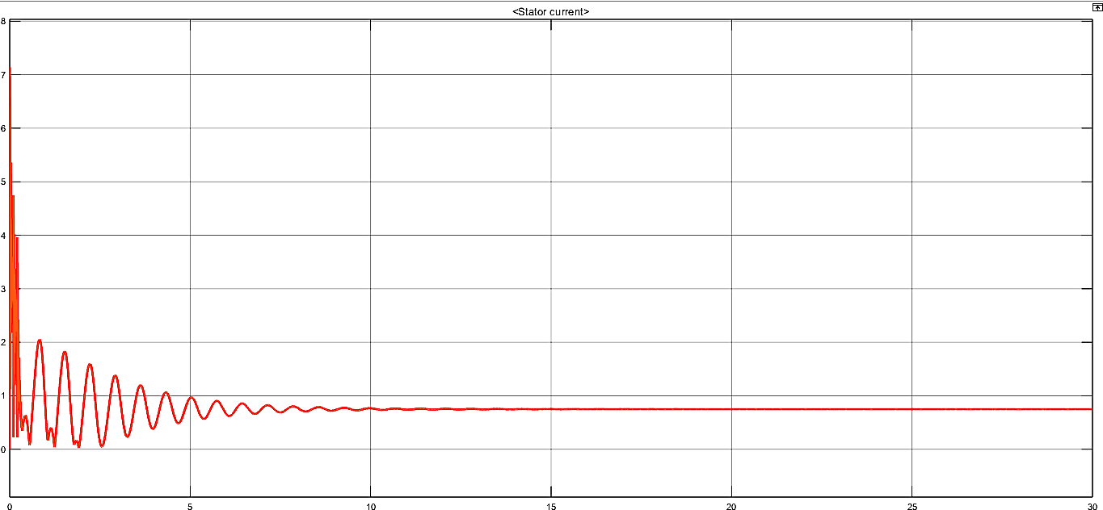

**Figure 13.6** Graph of Stator Current of Synchronous Machine

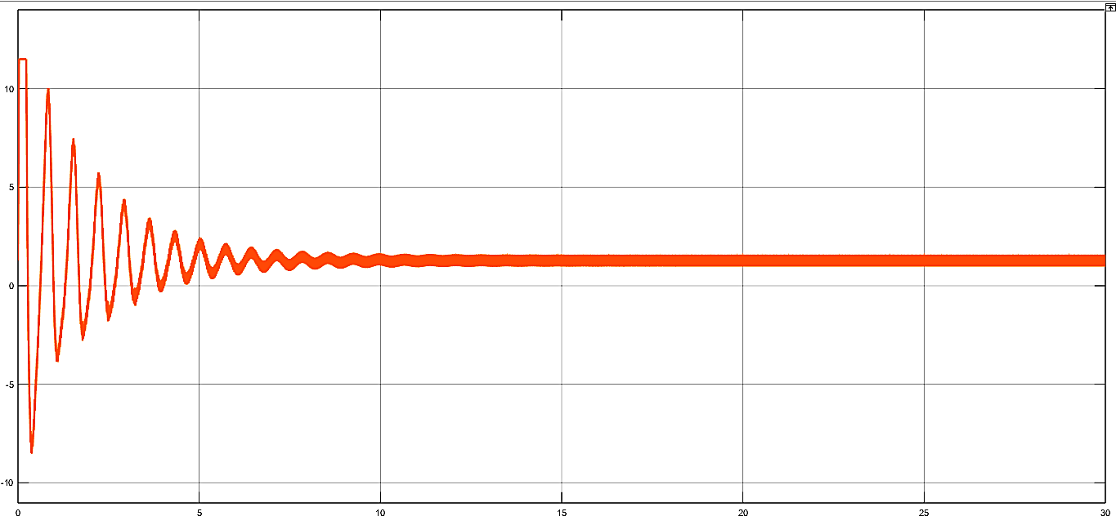

**Field Voltage:**

**Figure 13.7** Graph of Field Voltages of Synchronous Machine

# Observation and Conclusion:

In the lab, we have performed simulations and experiments to study the steady-state and stability behavior of synchronous machines. Through these exercises, we have gained valuable insights into the machine's behavior and performance under different operating conditions and disturbances. These insights will be useful in real-world applications, where the machine's reliable and efficient operation is critical to the power generation and transmission systems.

Overall, this lab has provided a comprehensive understanding of the steady-state and stability analysis of synchronous machines and their importance in ensuring reliable and efficient operation.